**Insurance Claims & Policyholder Risk Analysis Dashboard**

**1.Overview of the Dashboard**

This dashboard provides insights into insurance claims, policyholder risk factors, and claim severity. It is designed to help insurers analyze trends, optimize pricing, and make data-driven decisions. The key metrics include total claims, average claim amount, total claim adjustment, and claim severity distribution.

**2. Key Metrics & Insights**

* **Total Claims:** 4,972
* **Average Claims per Policyholder:** 0.50
* **Total Claim Adjustment:** 368K
* **Average Claim Amount:** 73.97

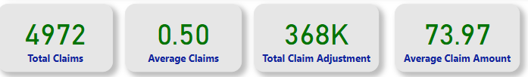

These figures provide an overview of the scale of claims and financial impact.

**3. Detailed Explanation of Each Visualization**

**a. Count of Records by Claims Severity**

* **Description:** This bar chart categorizes claims into **Low, Medium, and High severity**.
* **Insights:** Low-severity claims are the most frequent, followed by Medium and High severity claims.
* **Impact:** Insurers may focus on reducing high-severity claims through better risk management.

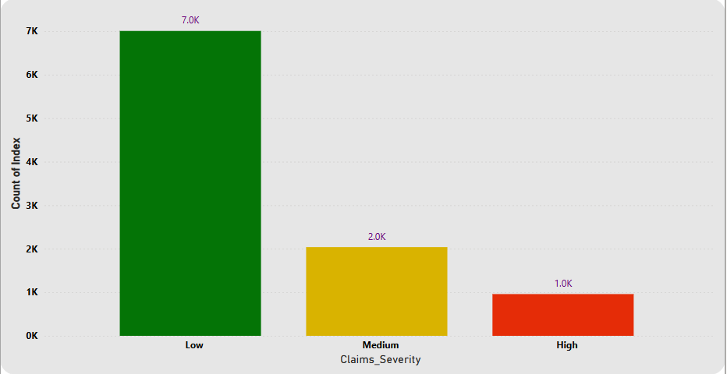

**b. Count of Records by Regions**

* **Description:** This donut chart represents claims distribution across **Urban, Suburban, and Rural areas**.
* **Insights:** The **Urban region has the highest claims (4.92K)**, followed by **Suburban (3.02K) and Rural (2.06K)**.
* **Impact:** Urban areas might pose higher risks, requiring premium adjustments.

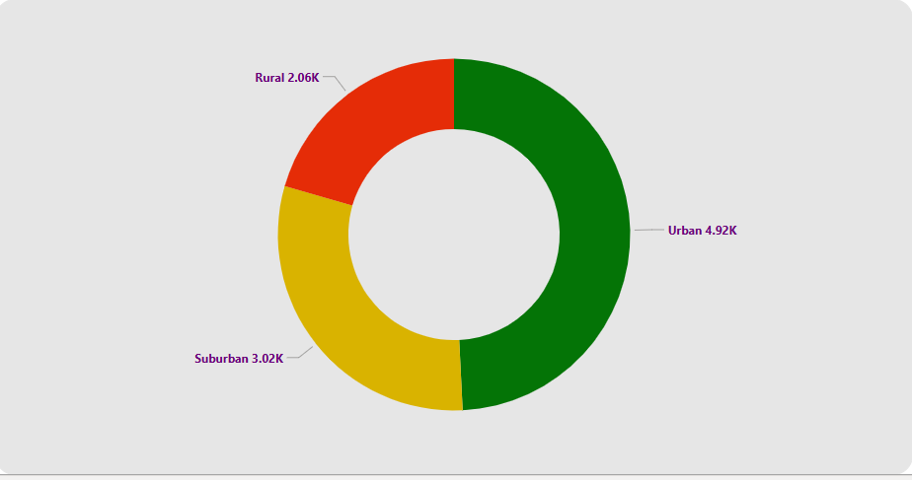

**c. Claims Frequency vs. Premium Amount**

* **Description:** A scatter plot showing the relationship between claim frequency and premium amount.
* **Insights:** Higher claim frequency often correlates with higher premiums.
* **Impact:** Helps in pricing adjustments for policyholders with frequent claims.

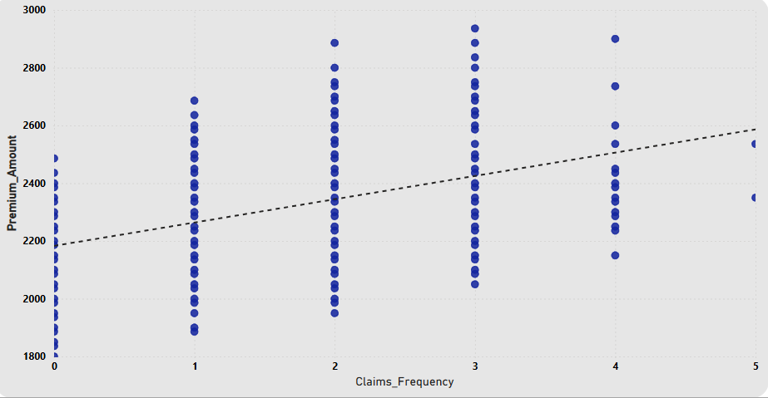

**d. Count of Records by Age (Bins) and Claims Severity**

* **Description:** A bar chart showing claim severity across different age groups and create a bins of age group of (0-5) years.
* **Insights:** Younger policyholders may have more low-severity claims, while older groups may have varied severity levels.
* **Impact:** Insurers can adjust policies based on age-based risk profiles.

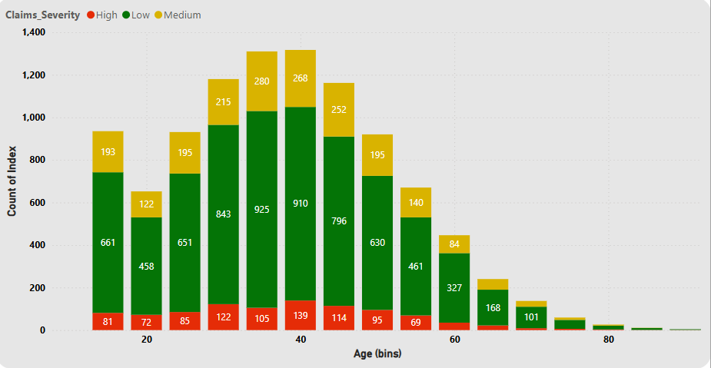

**e. Claims Severity by Region**

* **Description:** A stacked bar chart displaying the severity of claims across Urban, Suburban, and Rural areas.
* **Insights:** Urban areas have the highest severe claims, while Rural areas have fewer high-severity claims.
* **Impact:** Insurance companies can tailor risk management strategies per region.

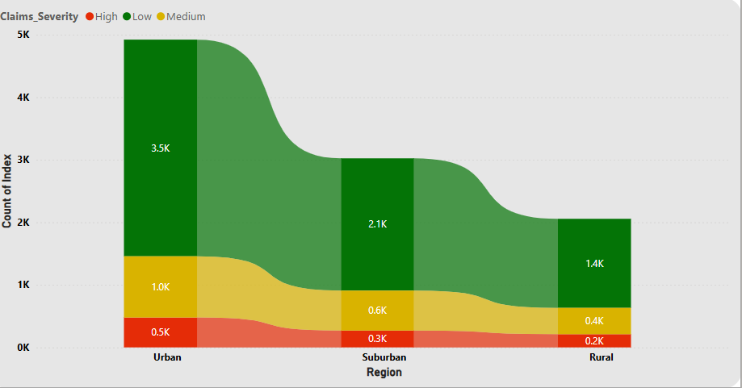

**4. Filters Used in the Dashboard**

Filters help users refine and analyze specific subsets of data, enabling a more focused approach to decision-making. The following filters are available in the dashboard:

**a. Policy Type**

* **Options:** Full Coverage, Liability-Only
* **Purpose:** Allows users to compare claim trends based on coverage type. Full Coverage policies may have different claim frequencies and severities compared to Liability-Only policies.

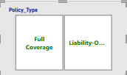

**b. Region**

* **Options:** Urban, Suburban, Rural
* **Purpose:** Helps analyze regional variations in claims, assisting in risk assessment and pricing strategies.

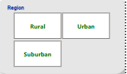

**c. Marital Status**

* **Options:** Single, Married, Divorced, Widowed
* **Purpose:** Identifies trends in claim filings based on marital status, which can impact policyholder risk profiles.

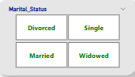

**d. Source of Lead**

* **Options:** Agent, Referral, Online
* **Purpose:** Examines whether different lead sources correlate with claim frequency or severity.

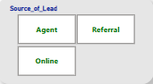

Filters enable dynamic analysis, allowing users to explore data from various perspectives and derive actionable insights.

**5. Analysis and Interpretation**

1. **Urban policyholders file more claims**, which may indicate higher risk levels.
2. **Frequent claimants tend to pay higher premiums**, as shown in the claims frequency vs. premium amount scatter plot.
3. **Age plays a role in claim severity**, with younger individuals filing lower-severity claims more frequently.
4. **Policy types and marital status impact claim behavior**, which insurers can use for policy adjustments.

**6. Key Takeaways & Recommendations**

* **Risk-Based Pricing:** Adjust premiums based on claim severity trends by age and region.
* **Fraud Detection:** Analyze frequent high-severity claims for possible fraudulent activities.
* **Policy Optimization:** Modify coverage options to reduce high-severity claims.
* **Customer Education:** Inform policyholders about safe practices to reduce claim frequency.

This dashboard provides actionable insights for improving claims management and policyholder risk assessment.